Zhuoyang Wan

COMP 3710, Assignment 1

Use Story: As a user, I want the application that coverts form Fahrenheit to Celsius or converts from Celsius to Fahrenheit.

Use Case:

|  |  |
| --- | --- |
| User Action | System reaction |
| Type number in the Fahrenheit | Get the number of Fahrenheit |
| Touch the “convert F to C” | * The result is calculated   Then display the number in the Celsius Field |
| Touch the “Clear” | * The system will display “” on the Fahrenheit Field and on the Celsius Field |
| Type number in the Celsius | * Get the number of Celsius |
| Touch the “convert C to F” | * The result is calculated * Then display the number in the Fahrenheit Field |

UI;

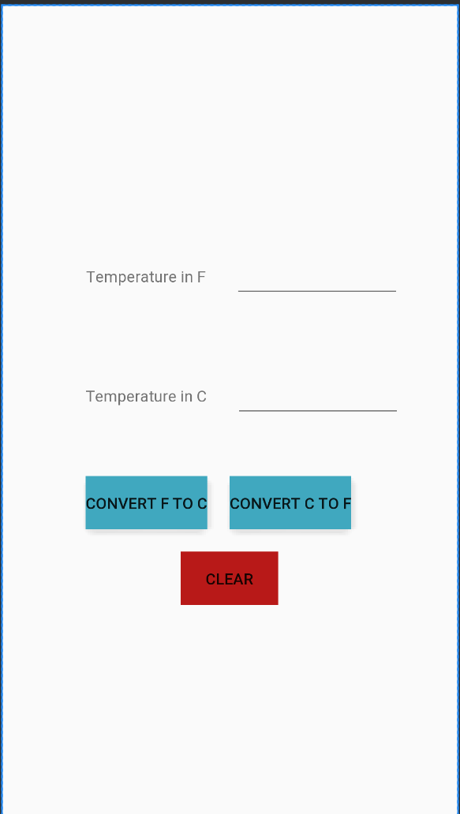

Screenshot:

